Triceps Stretch
This movement stretches all three heads of the triceps muscle. To make the stretch more intense, pull your elbow behind your head as far as possible while keeping the hand of the arm that is being stretched close to the shoulder.
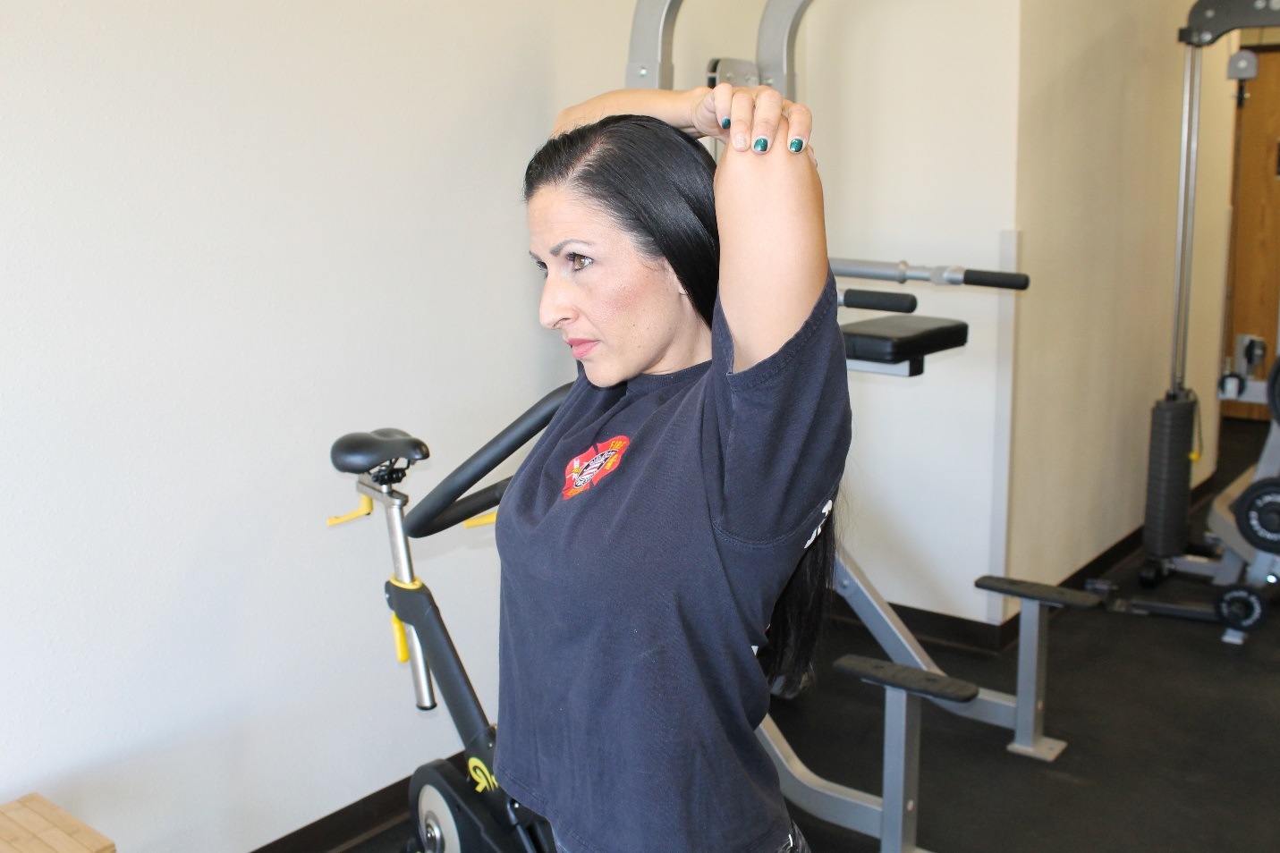

Shoulder Stretch
This stretch engages primarily your medial and posterior deltoid (shoulder) and is easy to execute. This is a stretch you should definitely perform as you workout as well. Simply press while pulling your opposite elbow towards your opposite shoulder.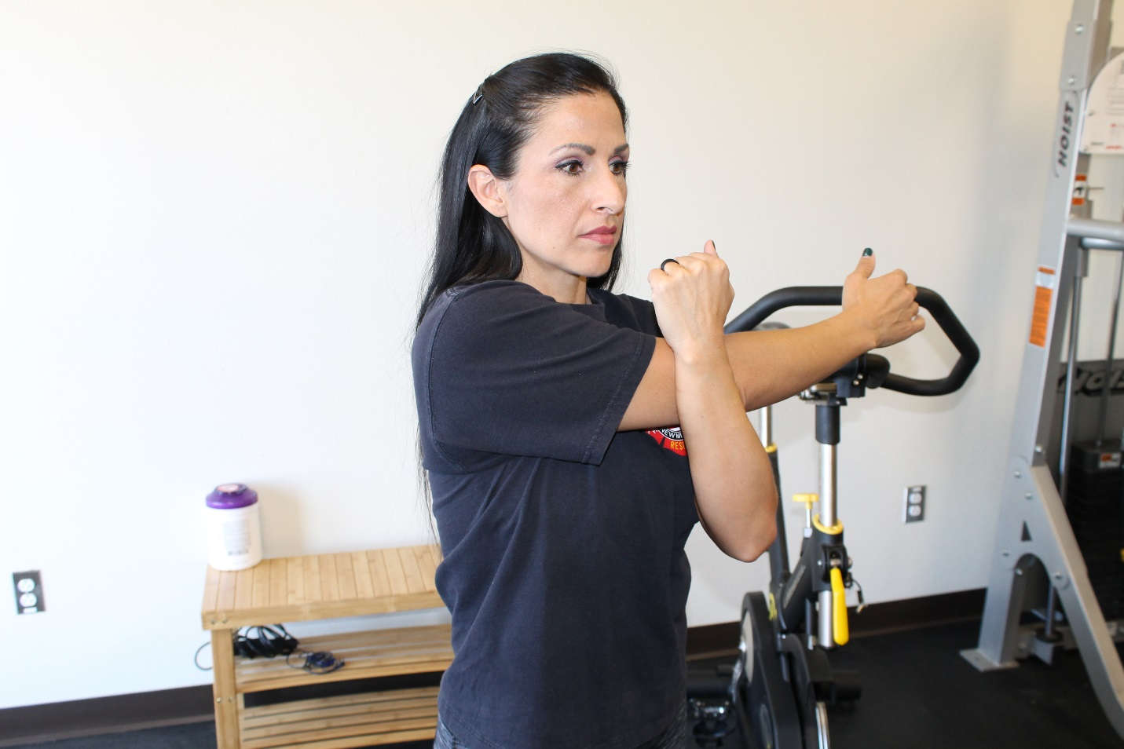

Lying or Standing Quad Stretch
Of all the stretches listed, this one you may consider doing while standing while holding on to your foot with both hands. I included both lying and standing. The further you bring your knee backwards, the more intense the stretch. The quadriceps are muscles on the front of your leg.
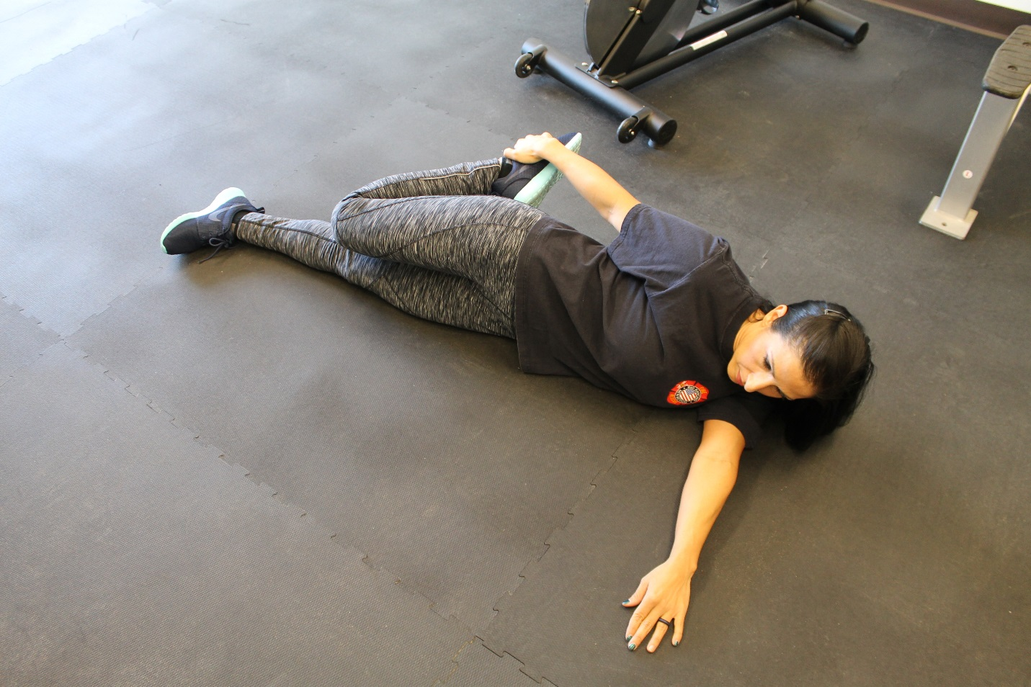
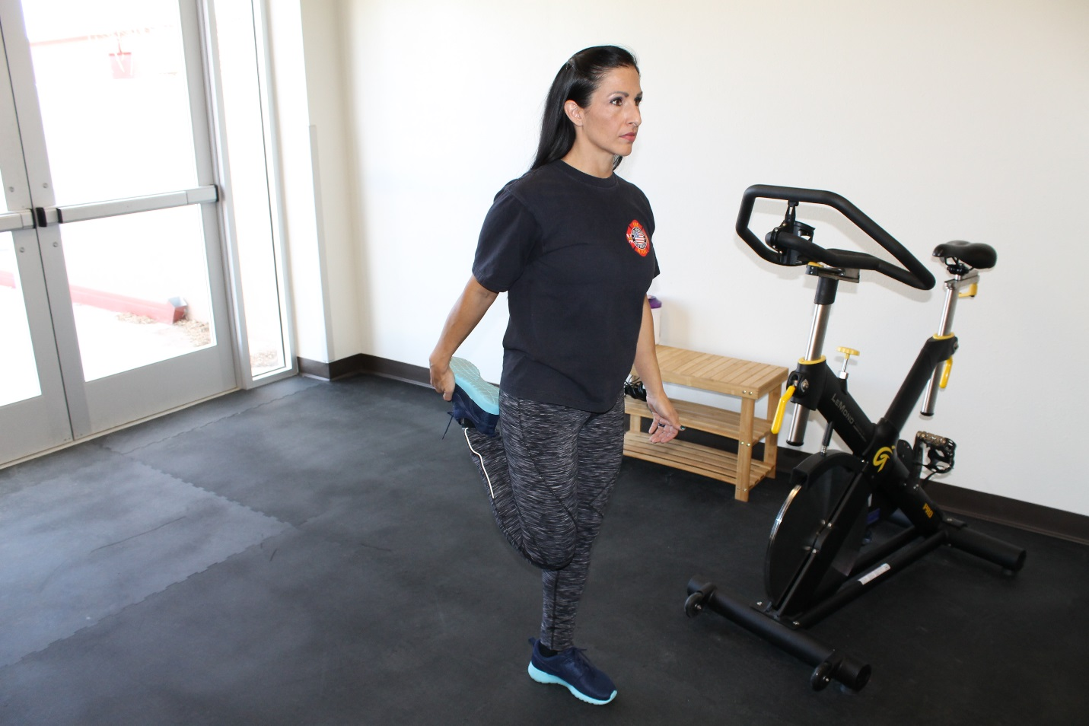

Lying Hip Stretch
Your hands are to be around the left knee to pull the right leg towards my body. This is a great hip stretch that I think you should incorporate into your routine. 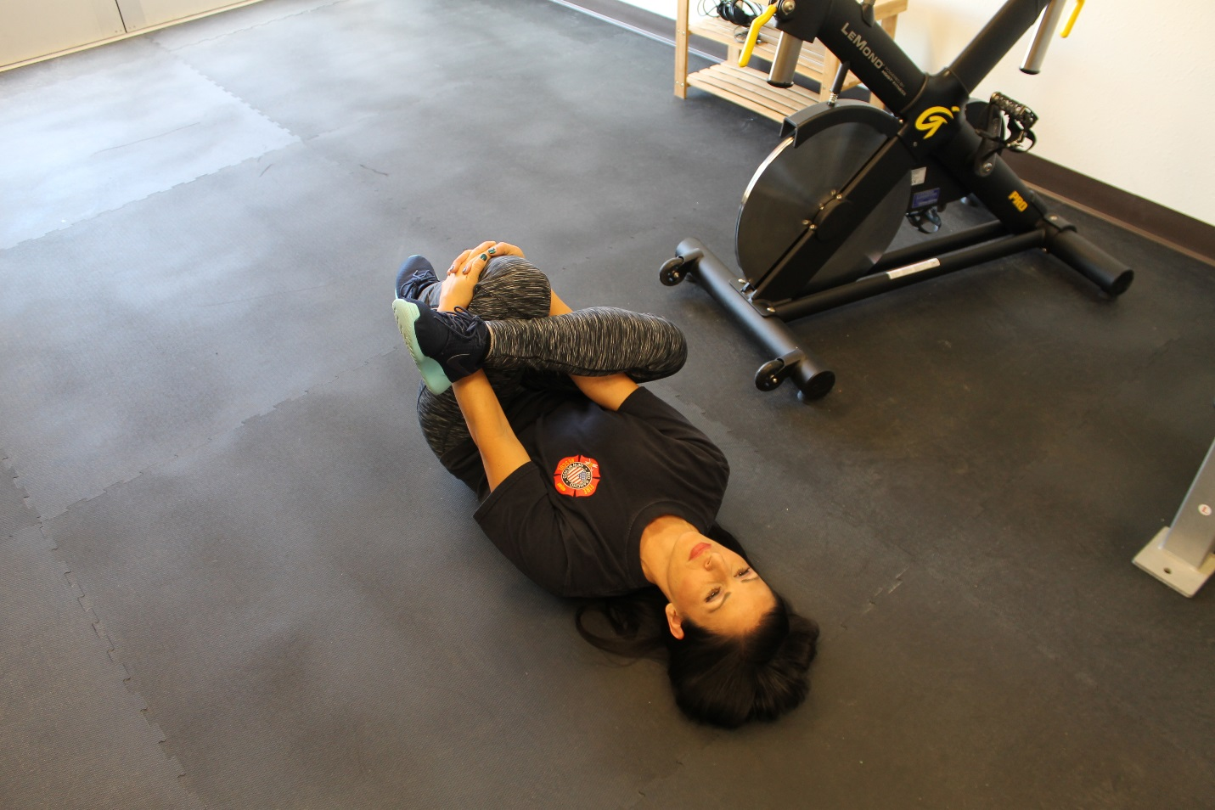

Butterfly Groin Stretch
I am pressing my elbows down in an effort to increase the stretch. The closer you put your feet to your body, the more intense the stretch will be.
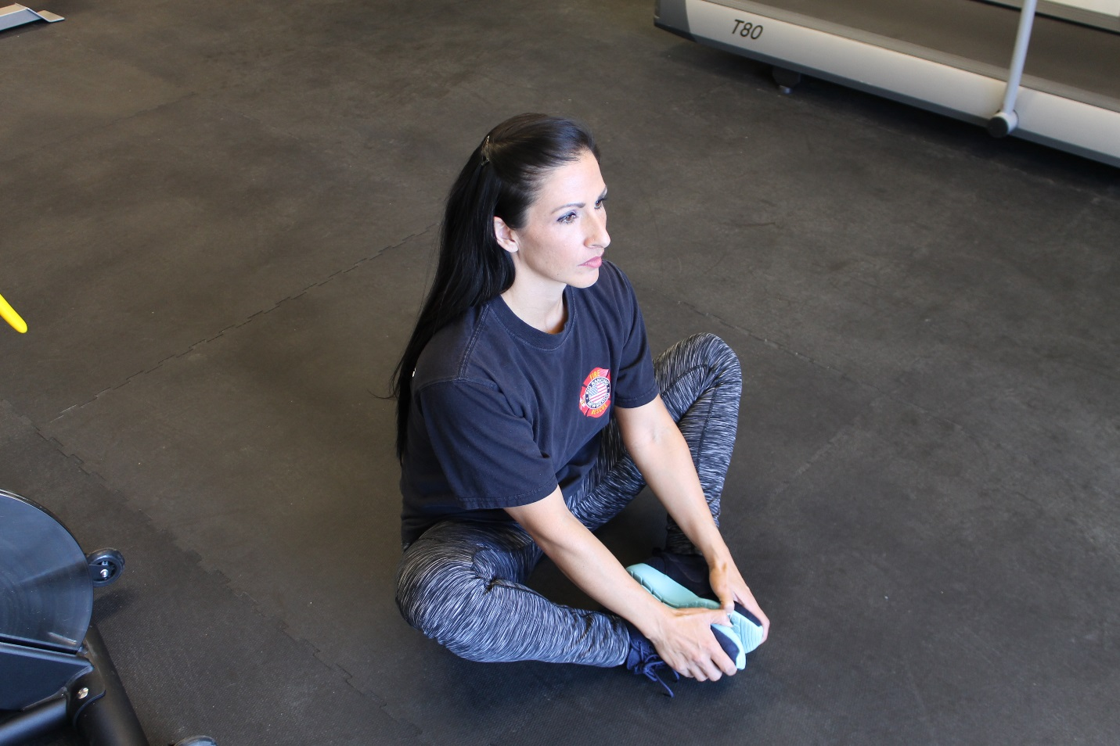

Revolving Lateral Angle Pose (Lunge Variation)
This is a more advanced stretch that you can work towards to, but very effective. This action creates a stretch surrounding the spine. Revolved Side Angle stretches, tones, and strengthens the entire body, inside and out. It stretches the thighs, knees, ankles, calves, groins, chest, and shoulders. This pose builds strength in the legs, as well, particularly in the quadriceps and ankles.
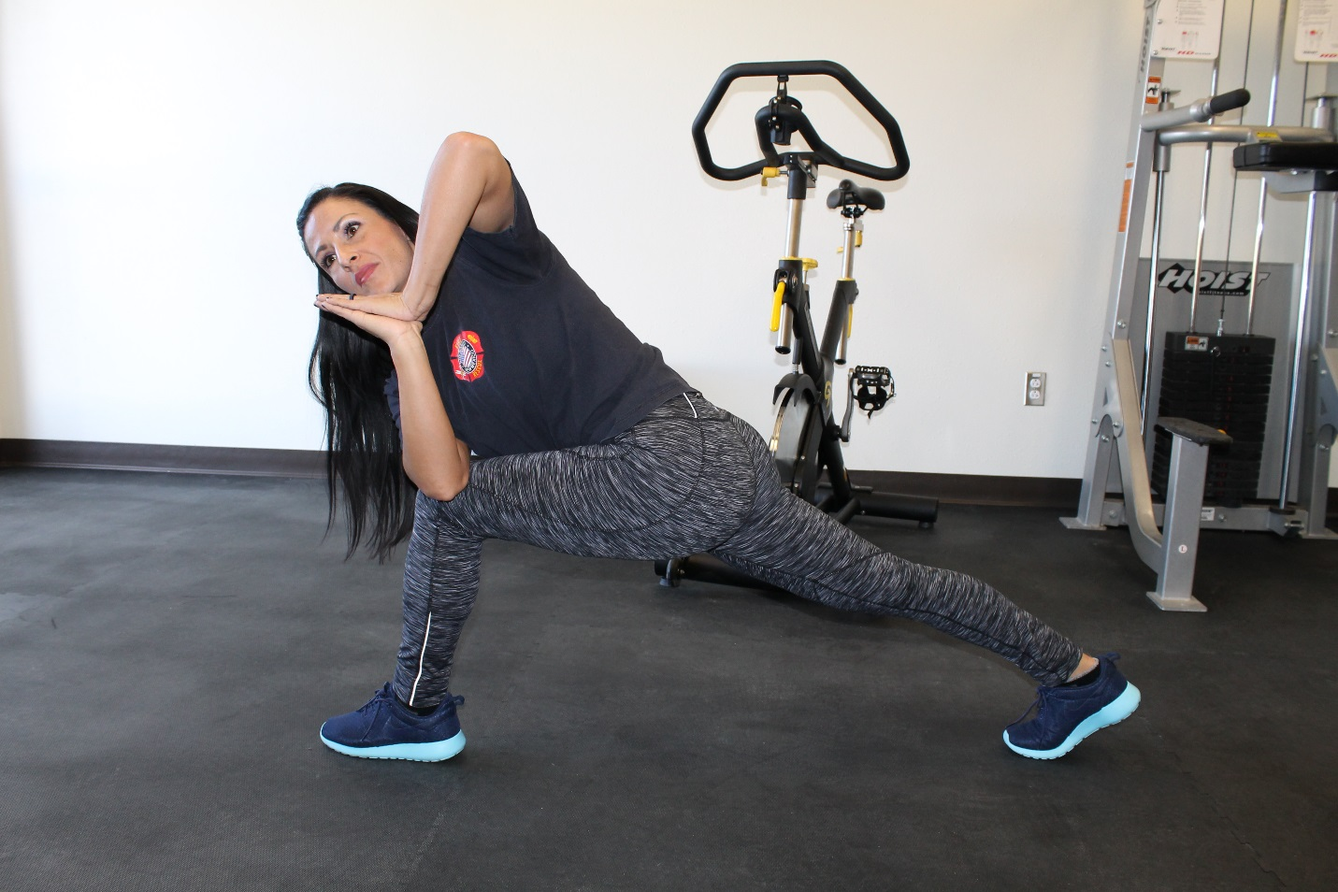

Pigeon Piriformis Stretch
The piriformis is a muscle in the gluteal region of the lower limb. The piriformis is a difficult-to-reach muscle that runs from your spine to the thigh bone. When it begins to push against your sciatic nerve, often due to too much sitting, it can cause excruciating pain. It really stretches the buttocks, lower back, and hamstrings.
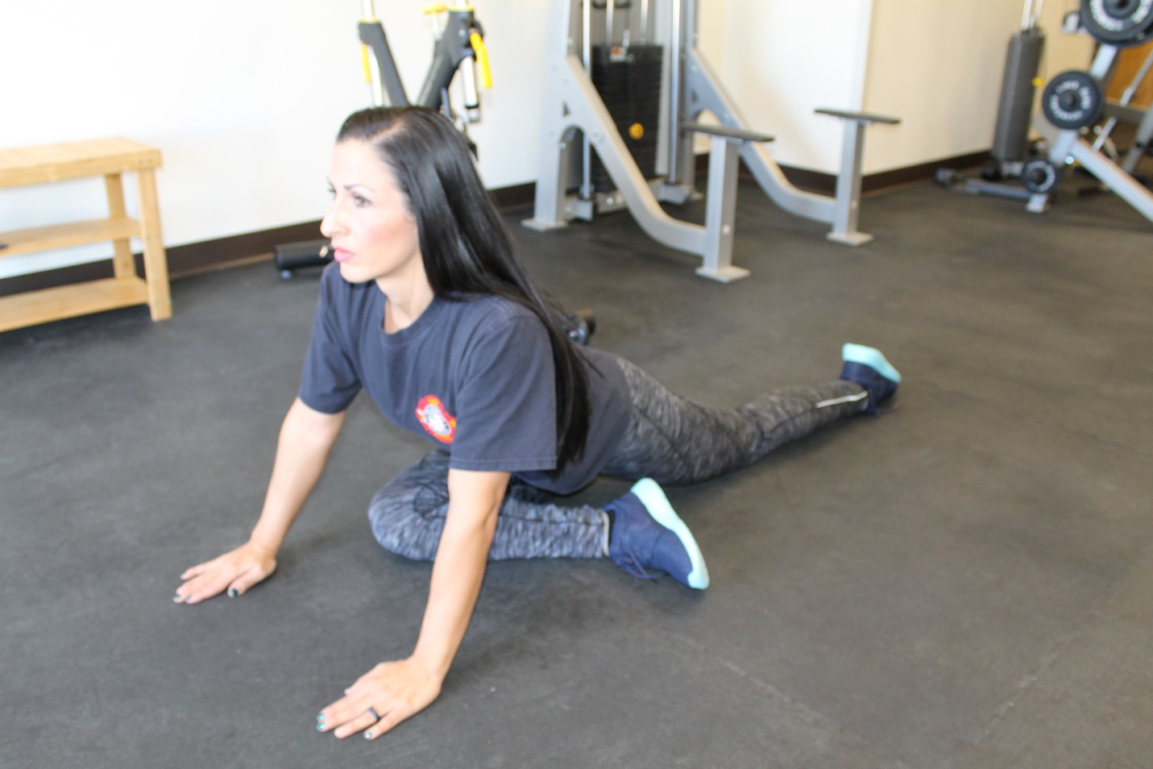

1 RM Bench Press Test
The purpose of the 1 RM Bench Press Test is to measure absolute strength of the upper body.
Procedures for Free Weight Bench Press
- Two experienced spotters must be used, one on each end of the bar.
- Starting weight for men is about 2/3 of body weight. Starting weight for women is the bar (45lbs).
- With member in supine position, spotters lower bar until member’s elbows reach 90 degrees. Member should have a slightly wider than shoulder width grip on bar.
- Spotters than release bar and member presses to full extension while exhaling.
- Spotters take bar, place on rack, and increase poundage.
- Repeat steps 3, 4, and 5 until 1 RM is reached. This should take approximately 5 to 6 trials.
- To compare to Cooper normative data convert the 1 RM free weight bench press score to the estimated 1 RM Universal bench press score by using the following formulas:
Males: Estimated 1 RM Universal = (1.016 x free weight 1 RM) + 18.41
Females: Estimated 1 RM Universal = (.848 x free weight 1 RM) + 21.37

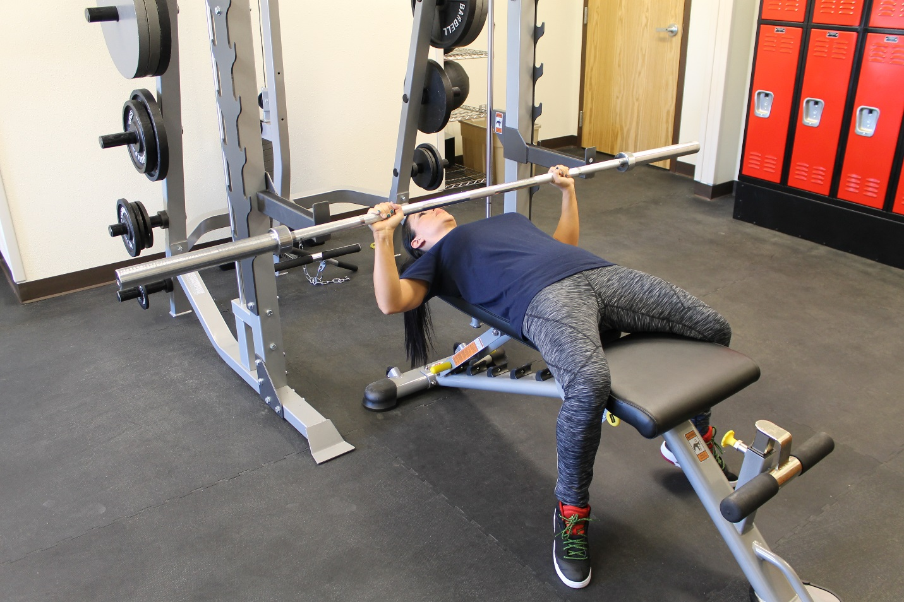
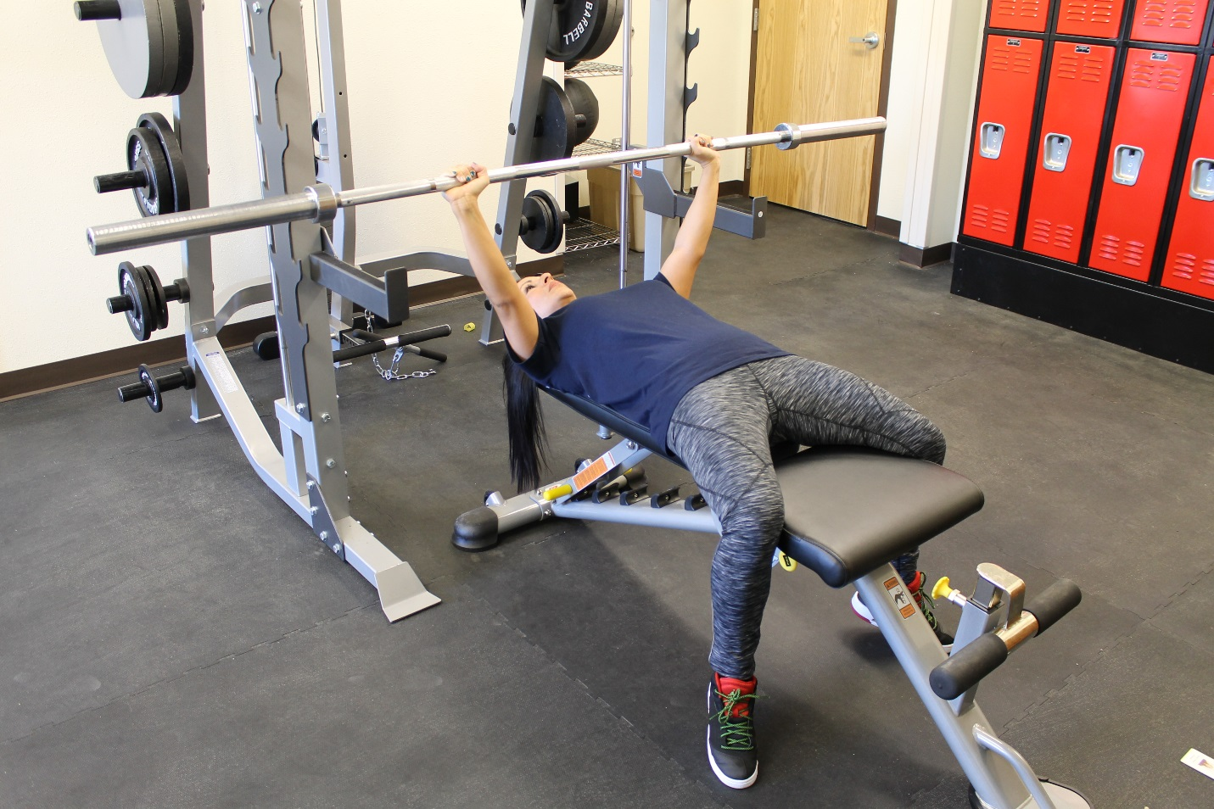

1 Minute sit-up Test
The purpose of this test is to measure abdominal muscular endurance.
Procedures
- The member starts by lying on the back with their knees bent, feet flat on the floor, with hands cupped behind the ears. Avoid pulling on the head with the hands. The buttocks must remain on the floor, with no thrusting of the hips.
- A partner holds the feet down firmly using their hands.
- The member then performs as many correct sit-ups as possible in 1 minute.
- In the up position, the member should touch elbows to knees and then return until the shoulder blades touch the floor. A correct sit-up will be counted each time the up position is met while maintaining proper form.
- The counter will announce each repetition out loud. If a repetition is not counted they will state why.
- Score is total number of correct sit-ups. Any resting should be done in the up position.
- Breathing should be as normal as possible. Exhaling on the way up and inhaling on the way down is strongly recommended. The member should not hold their breath.
- Neck remains in neutral position.
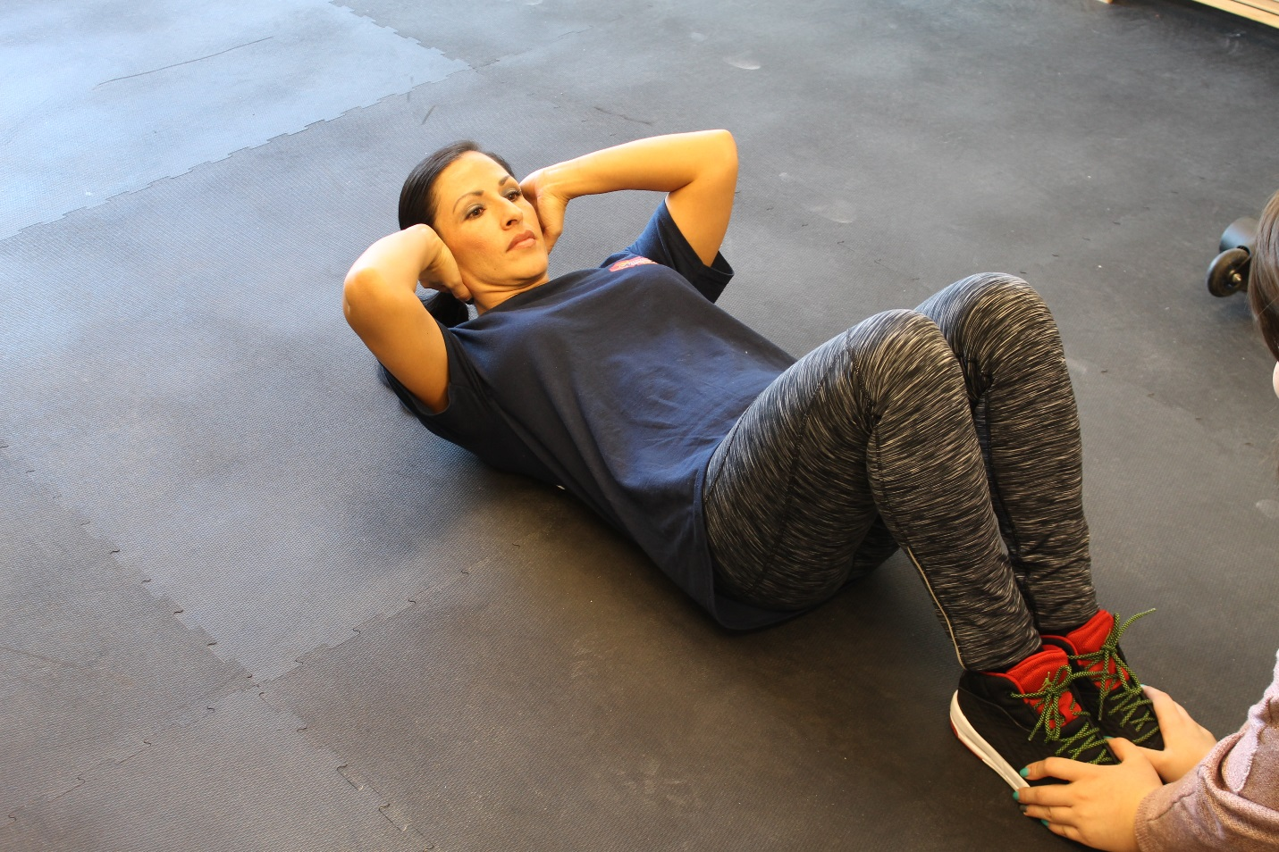
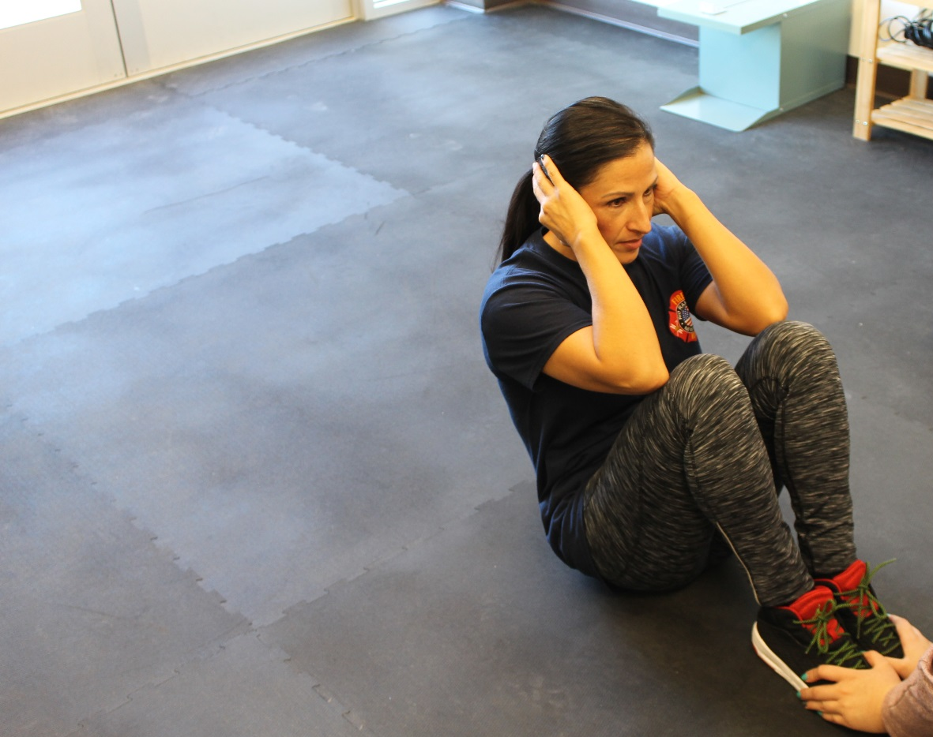

1 Minute Push-Up Test
The purpose of this test is to measure muscular endurance of the upper body (anterior deltoid, pectoralis major, triceps).
Procedures
- The hands are placed slightly wider than shoulder width apart, with fingers pointing forward. The administrator places one fist on the floor below the member’s chest. If a male is testing a female, a 3-inch sponge should be placed under the sternum to substitute for the fist. The feet are together and cannot be braced against a wall.
- Starting from the up position (elbows extended), the member must keep the back straight at all times and lower the body to the floor until the chest touches the administrator’s fist. Member then returns to the up position. This is 1 repetition.
- Resting should be done only in the up position. Both hands must remain in contact with the floor at all times. No piking or arching is allowed at any time; the back must be keep straight.
- The counter will announce each repetition out loud. If a repetition is not counted they will state why.
- The total number of correct push-ups in 1 minute is recorded as the score.

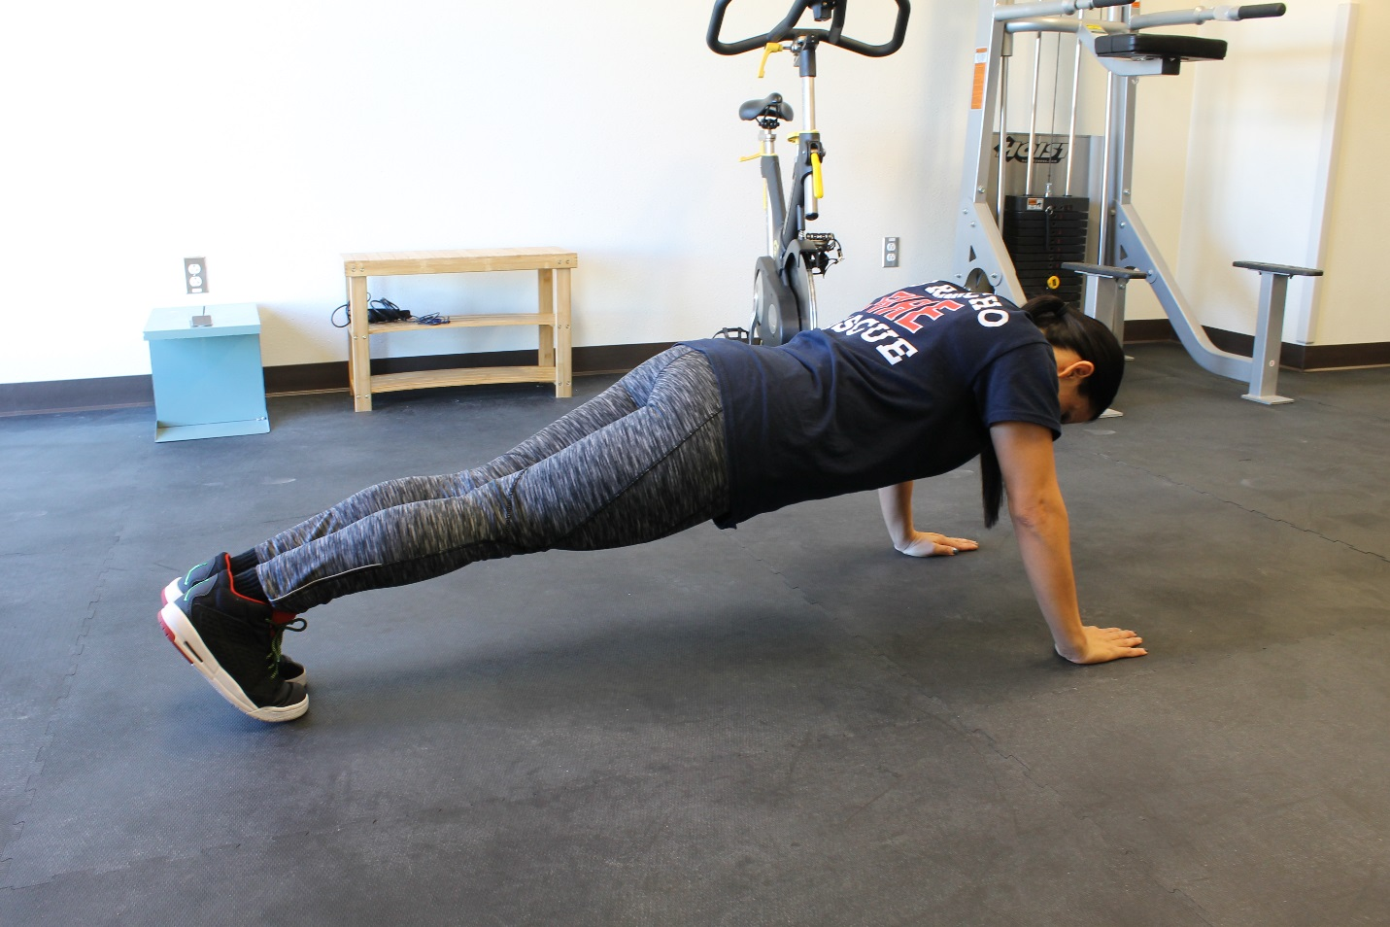
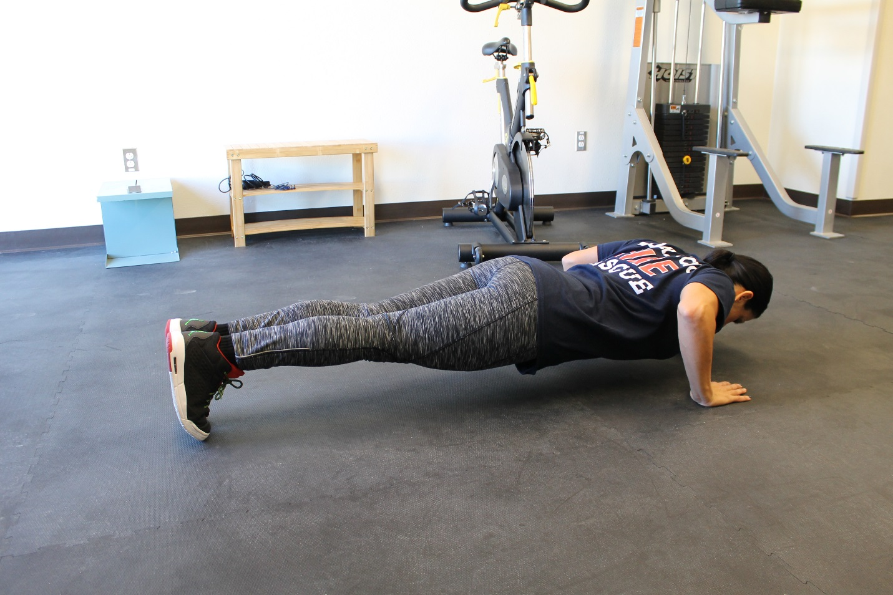

Sit-and-Reach Test
The purpose of the Sit-and-Reach Test is to measure hamstring flexibility.
Procedures
- The member should warm-up.
- The shoes must be removed.
- The feet are placed squarely against the box with the feet no wider than 8 inches apart. Toes are pointed directly toward ceiling.
- The knees remain extended throughout the test.
- The hands are placed one hand on top of the other, fingertips even.
- The

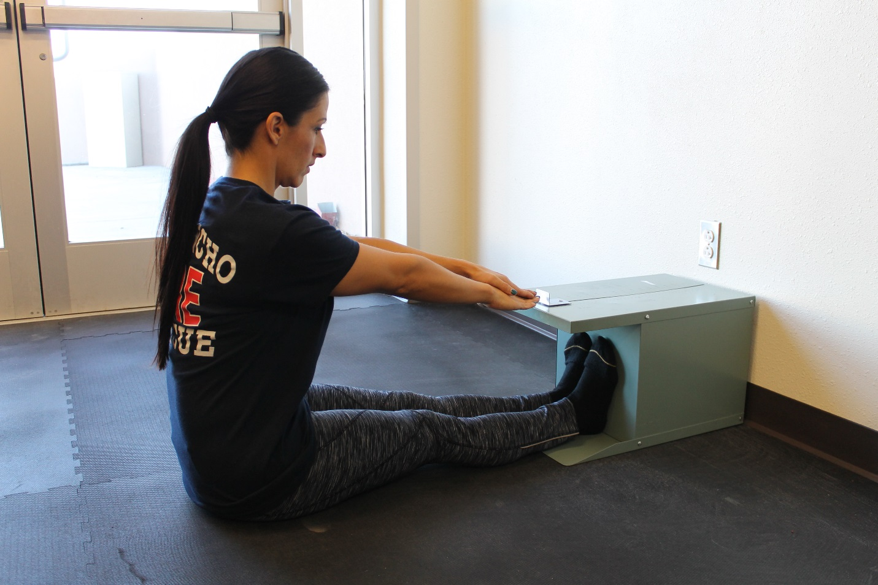
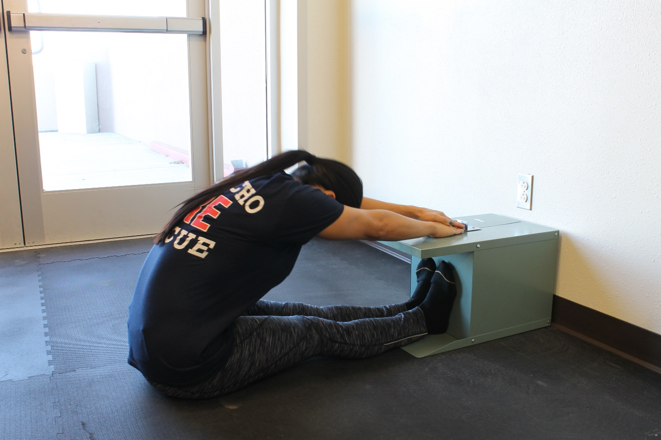

1.5 Mile Run Test
Procedures
- Members should not eat a heavy meal or smoke for at least 2-3 hours prior to the test. Members should perform a dynamic warm-up prior to the test.
- If possible, each member should have experienced some practice in pacing prior to the test. Often members will attempt to run too fast early in the run and become fatigued prematurely. A trained pacer might accompany the participants around the track during the actual test.
- The member runs 1.5 miles as fast as possible. If a 440 yard track is used, then 6 laps must be completed using the inside lane (lane 1). If using a 400 meter track, then an additional 15 yards must be run after the 6 laps are completed.
- During the administration of the test, the members can be informed of their lap times. Finish times should be called out and recorded.
- Upon test completion, a mandatory cool-down period is enforced. The members should walk slowly for about 5 minutes immediately after the run to prevent venous pooling (i.e., pooling of the blood in the lower extremities which reduces the return of blood to the heart and may cause cardiac arrhythmias).

